TASK-1

TITLE: Design and simulation of Basic ALU using Verilog HDL
OBJECTIVE: To design an ALU performing arithmetic and logical operations
OPERATIONS PERFORMED: 1. Addition
2. Subtraction
3. AND
4. OR
5.NOT
SOFTWARE USED: vivado
CODE:
VERILOG CODE FOR ALU:
`timescale 1ns / 1ps
//ALU PROGRAM
module task_1(
input [3:0]a,
input [3:0]b,
input [2:0]sel,
output reg [3:0]y
);
always@(*)
begin
case(sel)
3'b000 : y = a + b; //addition
3'b001 : y = a - b; //subtraction
3'b010 : y = a & b; //AND operation
3'b011 : y = a | b; //OR operation
3'b100 : y = ~a; //not operation
default: y = 4'b0000;//default case
endcase
end
endmodule

TESTBENCH FOR THAT VERILOG CODE:
`timescale 1ns / 1ps
//TESTBENCH FOR ALU
module task_1_tb( );
reg [3:0]a;
reg [3:0]b;
reg [3:0]sel;
wire [3:0]y;
task_1 uut(
.a(a),
.b(b),
.sel(sel),
.y(y)
);
initial begin
$monitor("a=%b b=%b sel=%b y=%b ",a,b,sel,y);
a=4'b0100; b=4'b0010; sel=3'b000; #10; //4+2=6(0110)
a=4'b0100; b=4'b0010; sel=3'b001; #10; //4-2=2(0010)
a=4'b0100; b=4'b0010; sel=3'b010; #10; //0(0000)
a=4'b0100; b=4'b0010; sel=3'b011; #10; //6(0110)
a=4'b0100; b=4'b0010; sel=3'b100; #10; //B(1011)
$finish;
end
endmodule
SEL | OPERATION | OUTPUT
000 | a + b | 0110
001 | a - b | 0010
010 | a & b | 0000
011 | a | b | 0110
100 | ~a | 1011
EXPECTED OUTPUT:

PRACTICAL OUTPUT:
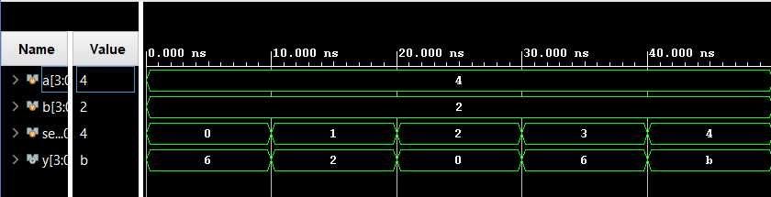

RESLUT:
ALU designed and simulated successfully.

